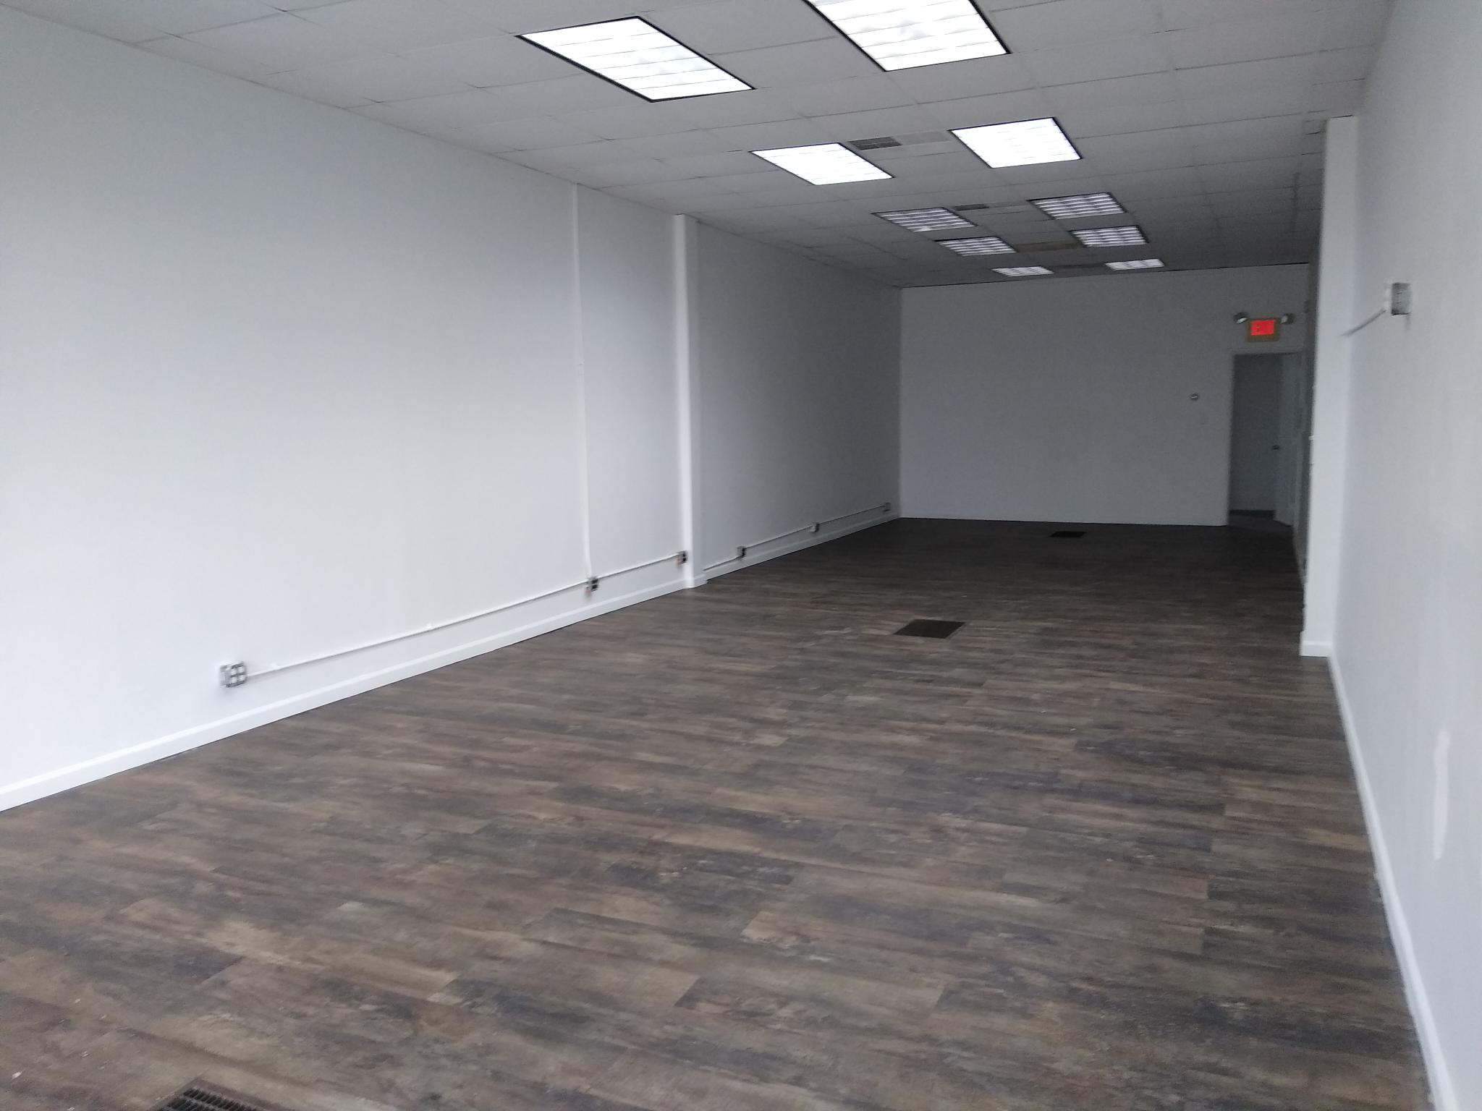
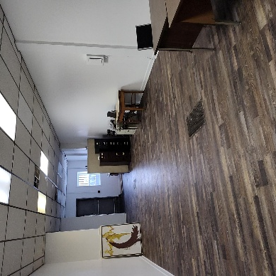
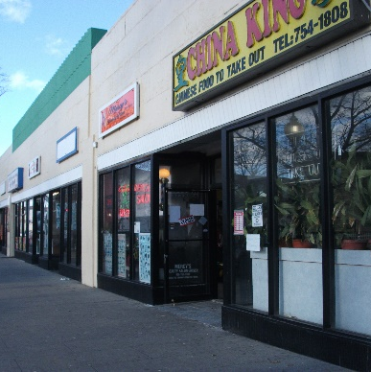
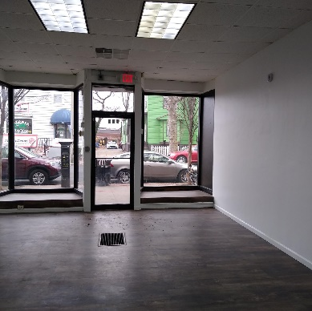
Retail Space – High-Visibility Location!
513A Park Avenue, Plainfield, NJ
LISTED BY OWNER
513A PARK AVENUE, PLAINFIELD, NJ 07060
Please call to arrange a private viewing. (267) 295-1969, or Response@513Park.com

Video Walkthrough Available:

https://youtube.com/shorts/sd8ZdEGrn_U
Newly updated, 1,050 sq. ft. whitebox space

High-traffic area on Park Avenue in downtown Plainfield.

Move-in ready and perfect for a variety of retail, office or flex uses.

10-min walk to train station

About Plainfield, NJ
Population: 55,467
Median Household Income: $80,334
County: Union
Accessible to Routes 28 and 22; and Intrastate 287
LEASE BY OWNER
$3,200
per month

